1. Download kidsblock，as shown below;

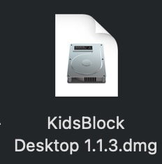

1. Double-click KidsBlock icon，then drag 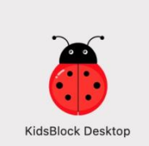 to the **Applications folder.**

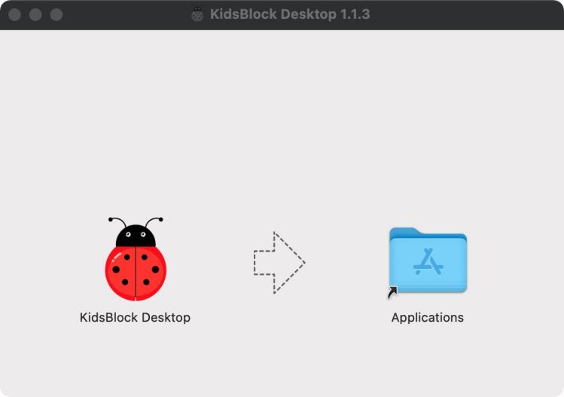

After the installation is finished, you will view KidsBlock icon.

